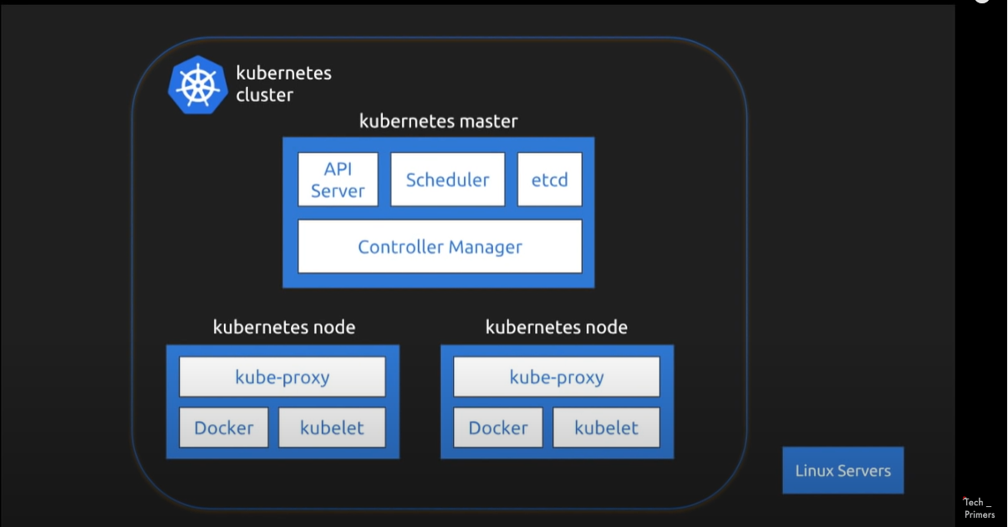

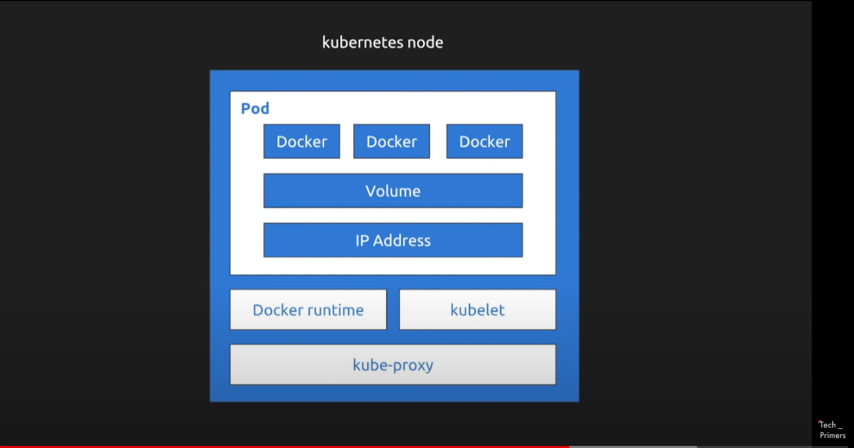

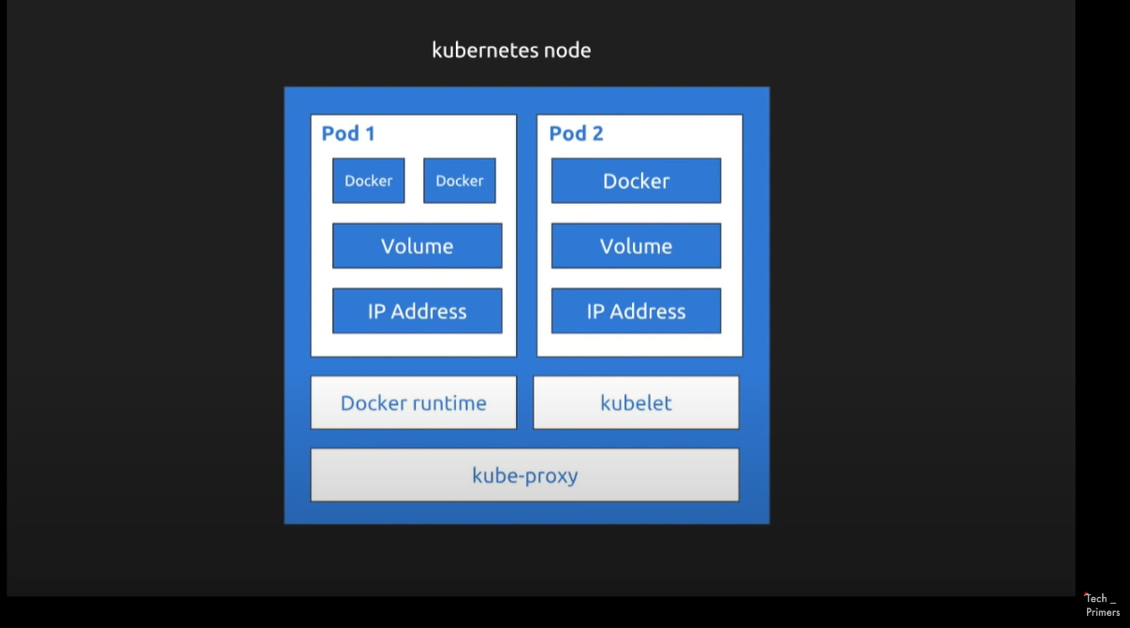

Work load Management

Workload: Any application running inside K8s cluster

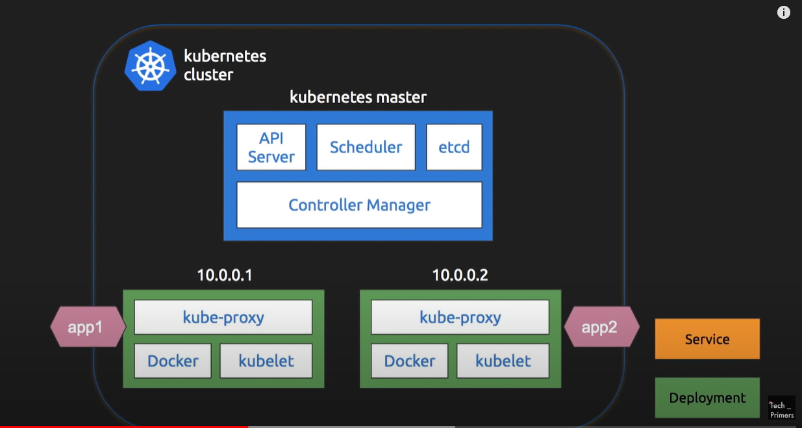

In case Pod 2 goes Down

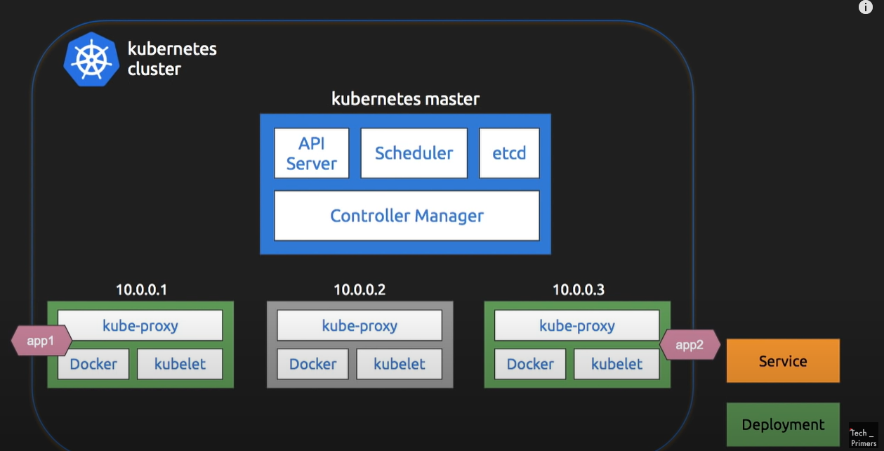

IP address Keeps on Changing So use Service

Connect to service – service has DNS name

**How to connect service ?**

Services are connected by Label Selectors

In case if App get destroyed new POD will be created with same Label hence service will be able to connect it

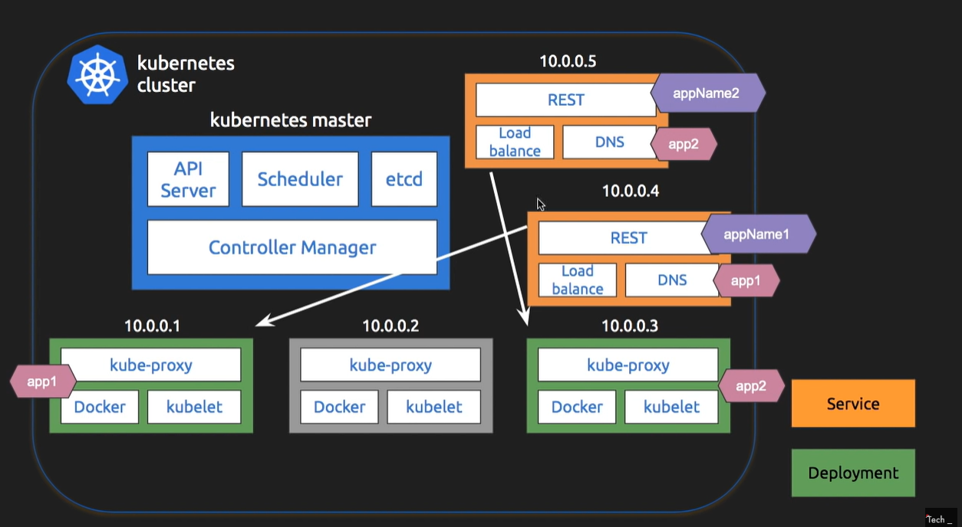

NOTE: Orange Boxes are service with name

Service will Do load balancing

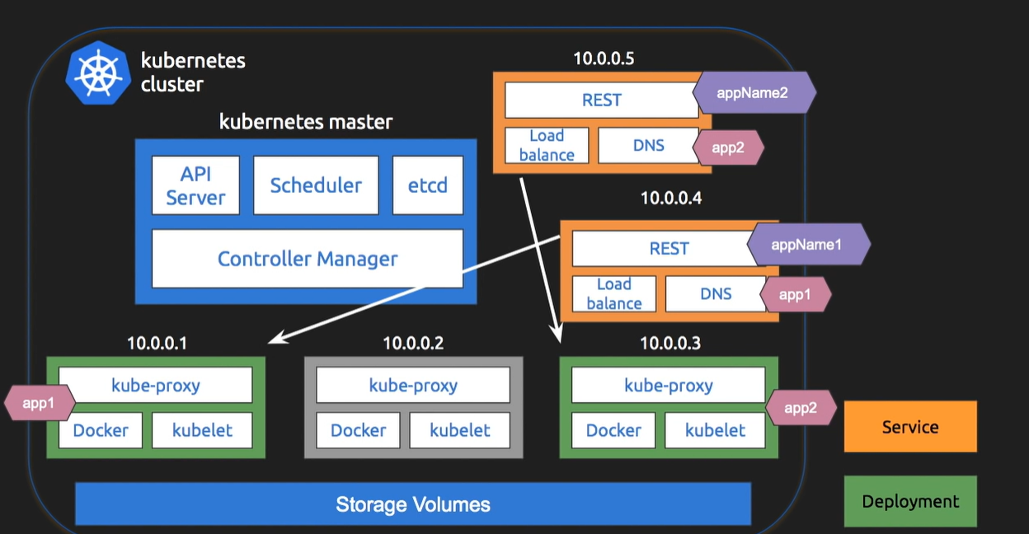

Common Storage Volume

Spring boot in K8S in Google Cloud

Google provides superior support to Kubernetes